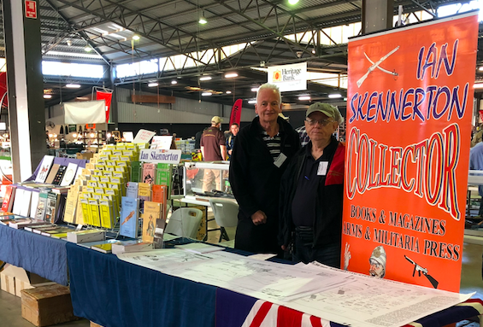
World Renowned Researcher and Author Ian Skennerton will, for the first time ever, be attending the 2019 Kumeu Militaria Show

Ian Skennerton was conscripted into the Australian Army in 1969 and served in Vietnam. He bought his first guns in the same year and continued to grow his collection and understanding of the many subtleties and intricacies of Enfield rifles and Bayonets for many years. And, also Bren Guns, Vickers Guns, LIA1s, Owen Guns and much more.

Realising that most British military and production source material was likely to be found in the ‘Mother Country’ Ian travelled there several times, including a 3 month and a 1½ year stints to:
- research full time at the Public Records Office and other libraries, and
- work and catalogue at the Tower of London, Imperial War Museum, National Army Museum and the Enfield Pattern Room.

Ian continues to travel far afield in search of more research material, photographs and movie material including to Britain, United States, Canada, New Zealand and Europe.

The ongoing result is a plethora of books, pamphlets, handbooks, magazines, DVDs and CD’s full of well researched and accurate material on most British Military Arms, Ammunition and Bayonets.

A full list of titles is available at http://www.skennerton.com/

Purchases in NZ are available via Graeme Barber his NZ distributer at http://gunshows.co.nz/wordpress/books/

Ian’s mantra is that
- that there is no substitute for first hand research material, and
- ‘buy the Rifle and not the Story’.

Therefore, for the discerning collector, his publications (be they hard covered, soft covered or digital) are pure ‘GOLD’.

Attending the Kumeu Militaria Show, with co researchers and writers Brian Labudda and Graeme Barber, Ian will be:
- selling his books (including some out of print and rare copies) and DVDs, and
- signing previously purchased books and sharing his knowledge.

We look forward to seeing you there!!!

